CMPUT 307

Quiz 1, Upload by Jan. 21, 2022 (max marks 76)

NAME: Mohammed Azad

1. [40] Consider an 10x10 image with six possible gray levels, 0,1,2,3,4,5 as shown below:

0 0 0 0 0 0 0 0 0 0

0 0 0 0 0 1 1 1 1 1

2 2 2 2 2 2 2 2 2 2

2 2 2 2 2 2 2 2 2 2

3 3 3 3 3 3 3 3 3 3

3 3 3 3 3 3 3 3 3 3

3 3 3 3 3 3 3 3 3 3

4 4 4 4 5 5 5 5 5 5

5 5 5 5 5 5 5 5 5 5

5 5 5 5 5 5 5 5 5 5

For parts (a) to (c) assume binary coding (i.e., only 0 & 1 transmitted).

1. [4] Calculate probabilities of the six gray levels.

Ans. Probability by level: 0(15%), 1(5%), 2(20%), 3(30%), 4(4%), 5(26%)

1. [4] What is the Entropy of this set of symbols?

Ans. Approximately 2.3032 to 5 s.f.

1. [12] Apply reduction process to derive the Huffman codes.

|  |  |  |  |  |  |
| --- | --- | --- | --- | --- | --- |
| **Symbol** | **Probabilities** | **Reduction 1** | **Reduction 2** | **Reduction 3** | **Reduction 4** |
| 4 | 0.04 |  |  |  |  |
| 1 | 0.05 | 0.09 |  |  |  |
| 0 | 0.15 | **0.15** | ***0.24*** |  |  |
| 2 | 0.20 | **0.20** | **0.20** | 0.44 | 0.44 |
| 5 | **0.26** | 0.26 | **0.26** | 0.26 | 0.56 |
| 3 | **0.30** | **0.30** | 0.30 | 0.30 |  |

|  |  |  |  |  |  |
| --- | --- | --- | --- | --- | --- |
| **Symbol** | **Code Step 5** | **Code Step 4** | **Code Step 3** | **Code Step 2** | **Code Step 1** |
| 4 | 1011 |  |  |  |  |
| 1 | 1010 | 101 |  |  |  |
| 0 | 100 | 100 | 10 |  |  |
| 2 | 11 | 11 | 11 | 1 | 1 |
| 5 | 01 | 01 | 01 | 01 | 0 |
| 3 | 00 | 00 | 00 | 00 |  |

1. [4] What is the Average Code length for the Huffman Codes in Part (b)?

Ans. 2.33

1. [4] What is the Efficiency of the Huffman coding for this specific problem? [Where Efficiency is defined as Entropy/(Average Huffman Code Length).]

Ans. 2.3032 / 2.33 = 0.98850 (to 5 s.f.)

1. [12] Instead of using the symbol reduction process in Part (c), use the Huffman Tree to generate the codes below.

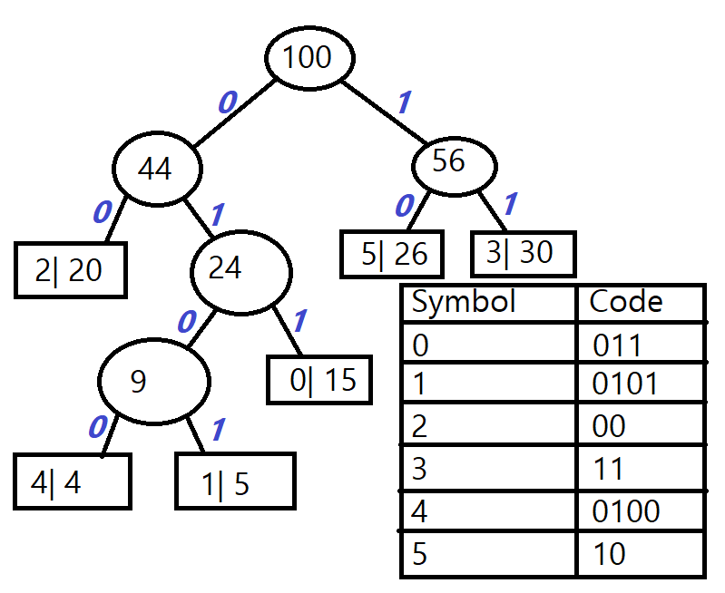

1. [36] **Arithmetic Coding**

Consider three symbols A, B, C and a string of 5 characters containing 3 Cs, 1 A, and 1 B coded using Arithmetic coding. Assume that the intervals for A, B, and C are arranged from top to bottom when the code is generated.

1. [10] Show below the steps involved in generating the message interval for CACBC.

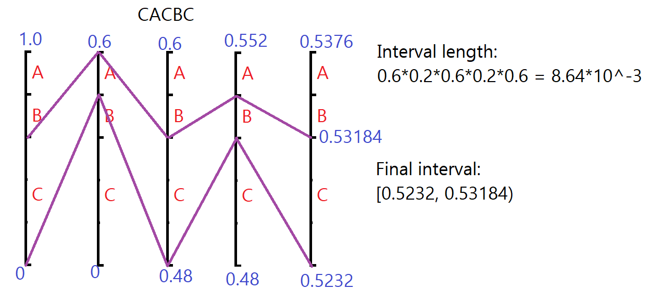

1. [10] Show below the steps involved in decoding the value 0.85.

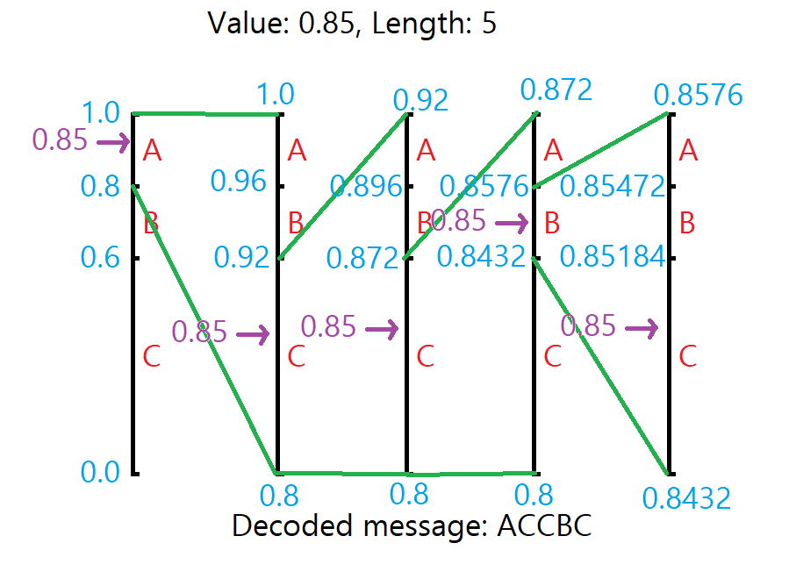

1. [6] What are the code intervals for the Arithmetic Codes given by “0010”, “1100” and “101”?

Ans. 0010 = [0.125, 0.15625)

1100 = [0.75, 0.78125)

101 = [0.625, 0.6875)

1. [10] Show below the steps involved in determining the Coding Interval from the Message Interval in Step (a). What is the Arithmetic Code for this Coding Interval?

Ans. $Code Length=\left[\log_{2}\frac{1}{8.64×{10}^{-3}}\right]+1=8$

Convert 0.5232 and 0.53184 to binary = 0.10000101111100000111 and 0.10001000001001101011

Truncating the lower bound to 8 decimal places = 0.10000101, which is 0.5195, lower than 0.5232, so we increase it to 0.10000111, which is 0.5273, greater than 0.5232.

Then we add an additional 1 to the last binary number and make sure that it does not exceed 0.53184.  
0.100001111 ≈ 0.5293, so the binary number 0.10000111 gives a range within the upper and lower bounds. Hence the encoded message will be

10000111